ABOUT DR. D. Y. PATIL GROUP:
A frontrunner in the education field, the Dr. D. Y. Patil Group is a name synonymous with world class quality education. The group strongly believes that world-class education is the stepping-stone to progress. With a long-standing commitment towards quality teaching and learning, the group has nurtured values that go into the making of successful careers. Equipped with state-of-the-art infrastructure, the group encourages its students to think, question, explore and apply their well-honed minds to scale newer heights of success. Dr. D. Y. Patil Group is a highly regarded as an educational organization having three deemed universities to its credit, and running nearly 160 educational institutions, in disciplines such as health care, management, engineering and technology. The group envisages inculcating skills that enable students to meet global level challenges.

DR. D.Y. PATIL TECHNICAL CAMPUS

(Affiliated to University of Pune, Approved by DTE, Govt. of Maharashtra and AICTE.)

As the demand for Engineers and Managers continues to grow, Dr. D. Y. Patil Technical campus is focused on preparing students for the infinite number of opportunities available. Our vision would surely make us the preferred institution in the country and abroad. This makes Dr. D. Y. Patil Technical Campus uniquely qualified to provide talented students, the type of broad technological and management education demanded in a rapidly changing world. Our programs would satisfy the demands of

employers that require a balance of rigorous fundamental engineering skills along with management talents in entrepreneurship, leadership, technical communication, team work and global awareness.

NSTITUTES UNDER TECHNICAL CAMPUS LOHEGAON

- Dr. D. Y. Patil School of Engineering
- Dr. D. Y. Patil School of Engineering & Technology
- Dr. D. Y. Patil School of Management
- Dr. D. Y. Patil School of Architecture
- Dr. D. Y. Patil School of MCA

EKALAVYA 2K14

A National level competition on “Innovative
Projects in Engineering Applications” at DYPSOE EKALAVYA 2K14 encourages entries for innovative projects to solve the problems of today needs in Industries, R&D and society.

Submission:
Submit 2-3 pages in pdf form which should
Includes:
- Abstract
- Objective and relevance of the project
- Block diagram and methodology
- Results
- References.
Send pdf at:- ekalavya.dypsoe@gmail.com
Mention subject area and department.
Important Dates:
Last date of Submission :20/03/2014
Notification to Selected Group: 21 /03/2014
Registration Formalities: 22/03/2014

Contact Details:
Prof. Malayaj Kumar (Mobile No. 9923886889)
Prof.Amarnath Patra (Mobile No. 7767984417)
Dr. D. Y. Patil Group of Institution’s
Dr. D. Y. Patil Technical Campus
Dr. D.Y. Patil School of Engineering
Charholi, Lohegaon, Pune-412105
Organizes
A National Level Competition
On
“Innovative Projects in Engineering Applications”
EKALAVYA 2K14
on
25th March 2014
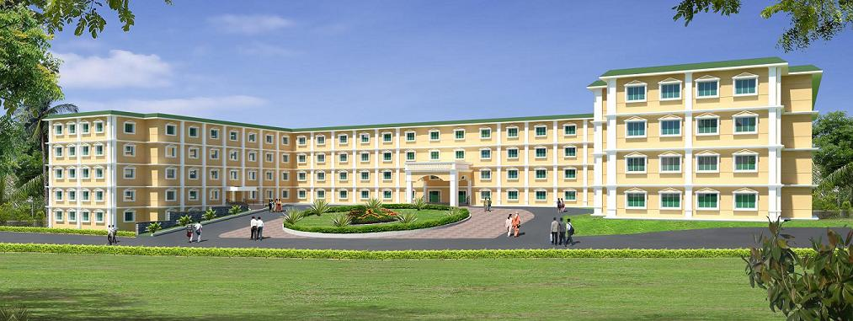
Dr. D. Y. Patil Knowledge City
Web: www.dypic.in
Phone: +91 20 30619454
Fax: +91 20 30619454

ELIGIBILITY

Third year and final year students of Engineering (Comp/IT, E&TC/Electronics, Mech/Auto/Prod, Civil)

REGISTRATION FEE:
The registration fees is Rs. 300/- per project group. It is to be paid in the form of Demand Draft drawn in favor of “Dr. D. Y. Patil School of, Engineering Pune”, payable at Pune.

CERTIFICATE
All participants will get Certificates of participation in innovative project competition

PRIZES

 | E&TC | COMP | CIVIL | MECH
1st Prize (Rs) | 3000/- | 3000/- | 3000/- | 3000/-
2nd Prize  (Rs) | 2000/- | 2000/- | 2000/- | 2000/-
3rd Prize  (Rs) | 1000/- | 1000/- | 1000/- | 1000/-

ADVISOR COMMITTE
- Dr. G. K. Kharate (Dean, faculty of Engg. UOP)
- Dr. D. S. Bormane (Chairman, BOS E & TC)
- Dr. Sarang Joshi (Chairman, BOS Comp)
- Dr. Sunil Kute (Chairman, BOS Civil)
- Dr. V. J. Kakhndaki (Chairman, BOS Mech)
- Dr. D. D. Shah (Principal,GHRCEM, Pune)
- Dr. D. M. Yadav(Principal, BSIOTR)
- Dr. R. D Khardkar(Principal, GHRIET, Pune)
- Dr. V. J. Awasare (Principal MMIT Lohegaon)
- Dr. Y. J. Bhalerao(Principal, MACOE Alandi)
- Dr. B. P. Patil (HoD, AIT Pune)

CHIEF PATRON

Dr. Ajeenkya DY Patil
Chairman Dr. D. Y. Patil Group
PATRON
Prof. B. G. Bhandarkar
(Director, Corporate Relations Dr. D. Y. Patil
Group of Inst. Lohegaon, Pune)

CONVENER
Dr. S. S. Sonavane
(Director, Dr. D. Y. Patil Technical Campus, Lohegaon, Pune)
COORDINATORS:
Prof. B. K.Shiragapur (HOD, E & TC)
Prof. Pranav Makashare (HOD, Mech.)
Prof. A. R Kolhe (HOD, Civil)
Prof. P. M. Agarkar (HOD, Comp)
Prof. A. P. Deshmukh (Dean Dypsoe)
Prof. K. H. Munde (FE coordinator)

ORGANIZING SECRETARY
Prof. Riyaj Kazi
Email :riyaj.kazi@dypic.in
Contact: 9881839335

ORGANIZING COMMITTEE

E&TC Engg.
Prof Anil Wanare
Email: anil.wanare@dypic.in
Contact: 9922959236
Landline: 020 30619476

MECHANICAL Engg.
Prof. Mahesh Dandnaik
Email: mahesh.dandnaik@dypic.in
Contact:9823630125
Landline: 020 30619458

Civil Engg.
Prof. R. T. Koshti
Email: ramakant.koshti@dypic.in
Contact:7309291933
Landline: 020 30619474

Computer Engg.
Prof. Monika Dangore
Email : monika.dangore@dypic.in
Contact:9545554530
Landline: 020 30619462

Dr. D. Y. Patil Group of Institutes
Dr. D. Y. Patil Technical Campus
Dr. D.Y. Patil School of Engineering
Dr. D. Y. Patil Knowledge City Lohegaon, Pune-412105
EKALAVYA 2K14

25th March 2014
APPLICATION FORM

- Names of Project Leader:

___________________________________

Name of College:______________________

Department: _________________________

Class: _______________________________

Address of the College: ________________

- Project title:
__________________________________________________________________________

- Name of Guide:
_____________________________________

4. Communication Details:
Mobile: …………………………………
E-mail: …………………………………
6. PAYMENT DETAILS
DD No: _____________________
Dated: _______________________
Name of the Bank: __________________
Amount: _________________________

Place: Date:

Signature of the Applicant

